Chapter 4: Device Management
An Operating System manages device communication via their respective drivers.
The main functions of an operating system is to control all the computer's I/O devices
- It must issue commands to the devices, catch interrupts, and handle
errors.
- It should also provide an interface between the devices and the rest of the system that is
simple and easy to use.
- Keep tracks of all devices and the program which is responsible to perform this is called I/O controller.
- Monitors the status of all devices. Including storage drivers, printers and other peripheral devices
- Decides which process gets the device when and for how much time.
- Allocates and de-allocates the device in the efficient way.
Principles of I/O HARDWARE
Different people look at I/O hardware in different ways. Electrical engineers look at it in terms of chips, wires, power supplies, motors, and all the other physical components that make up the hardware. Programmers look at the interface presented to the software the commands the hardware accepts, the functions it carries out, and the errors that can be reported back. From these our focus is on Programming I/O devices i.e how the hardware is programmed.
A device communicates with a computer system by sending signals over a cable or even through the air.
The device communicates with the machine via a connection point termed a port (for example, a serial port). If one or more devices use a common set of wires, the connection is called a bus. In other terms, a bus is a set of wires and a rigidly defined protocol that specifies a set of messages that can be sent on the wires.

Basic of I/O Devices
I/O devices can be roughly divided into two categories: block devices and character devices.
- BLOCK device can be defined as one that stores information in fixed-size blocks, each one with its own address. e.g. Hard disks, CD-ROMs, and USB
- CHARACTER device delivers or accepts a stream of characters, without regard to any block structure. e.g. Printers, NIC, and mice
Some typical device, network and bus data rates.
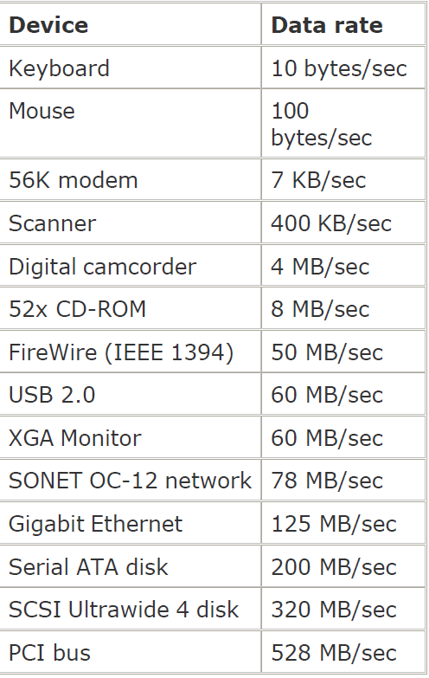
Device Controllers
I/O units typically consist of a mechanical component and an electronic component. This
electronic component is called the device controller or adapter
A controller is a collection of electronics that can operate a port, a bus, or a device. A serial-port controller is an example of a simple device controller.
- Converts between serial bit stream and a block of bytes
- Performs error correction if necessary
A model for connecting the CPU, memory, controllers, and I/O devices
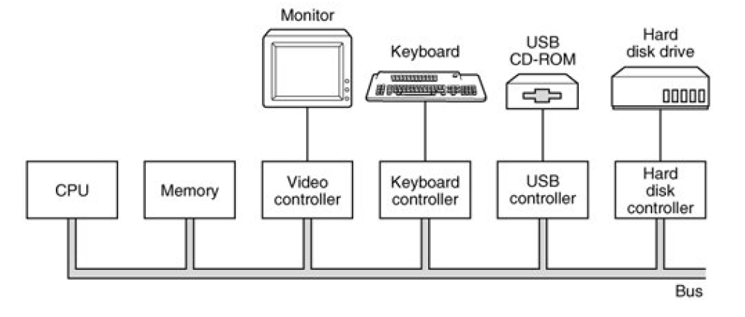
The controller card usually has a connector on it, which a cable leading to the device itself can be plugged. Many controllers can handle two, four, or even eight identical devices. If the interface between the controller and device is a standard interface, then companies can make controllers or devices that fit that interface.
Most personal computers and servers use the bus model for communication between the CPU and the controllers. Large mainframes often use a different model, with specialized I/O computers called I/O channels taking some of the load off the main CPU.
Memory-Mapped I/O
- Each controller has few registers used for communicating with the CPU.
- By writing into theses registers, the operating system can command the device to deliver data, accept data, switch itself on or off.
- By reading from these registers, the operating system can learn what the device's state is, whether it is prepared to accept a new command.
- In addition to the control registers, many devices have a data buffer that the operating system can read and write.
How the CPU communicates with the control registers and the device data buffers.
In the first approach, each control register is assigned an I/O port number. Using a special I/O instruction such as
- IN REG,PORT the CPU can read in control register PORT and store the result in CPU register REG. Similarly, using
- OUT PORT,REG the CPU can write the contents of REG to a control register.
when the CPU wants to read a word, either from memory or from an I/O port, it puts the address it needs on the address lines of the bus and then asserts a READ signal on a bus control line. A second signal line is used to tell whether I/O space or memory space is needed.
Direct Memory Access (DMA)
The operating system can only use DMA if the hardware has a DMA controller. Sometimes this controller is integrated into disk controllers and other controllers, but such a
design requires a separate DMA controller for each device. more commonly a single DMA controller is available (e.g., on the parent board) for regulating transfers to multiple devices, often concurrently. the DMA controller has access to the system bus independent of the CPU
It contains several registers that can be written and read by the CPU. These include a memory address register, a byte count register, and one or more control registers.
The control registers specify the I/O port to use, the direction of the transfer (reading from the I/O device or writing to the I/O device), the transfer unit (byte at a time or word at a time), and the number of bytes to transfer in one burst
Operation of a DMA transfer.

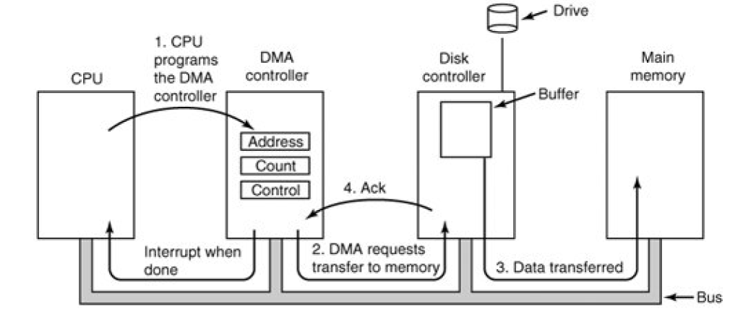

How DMA works:
First the CPU programs the DMA controller by setting its registers so it knows what to transfer, where (Step1)
It also issues a command to the disk controller telling it to read data from the disk into its internal buffer and verify the checksum. When valid data are in the disk controller's buffer, DMA can begin
The DMA controller initiates the transfer by issuing a read request over the bus to the disk
controller (step 2)
The write to memory is another standard bus cycle (step 3).
When the write is complete, the disk controller sends an acknowledgement signal to the disk controller, also over the bus (step 4).
why the controller does not just store the bytes in main memory as soon as it gets them from the disk. There are two reasons
First, by doing internal buffering, the disk controller can verify the checksum before starting a transfer
The second, once a disk transfer has started, the bits keep arriving from the disk at a constant rate, whether the controller is ready for them or not. If the controller tried to write
data directly to memory, it would have to go over the system bus for each word transferred. If the bus were busy due to some other device using it, the controller would have to wait

I/O port
An I/O port typically consists of four registers, called the status, control, data-in, and data-out registers.
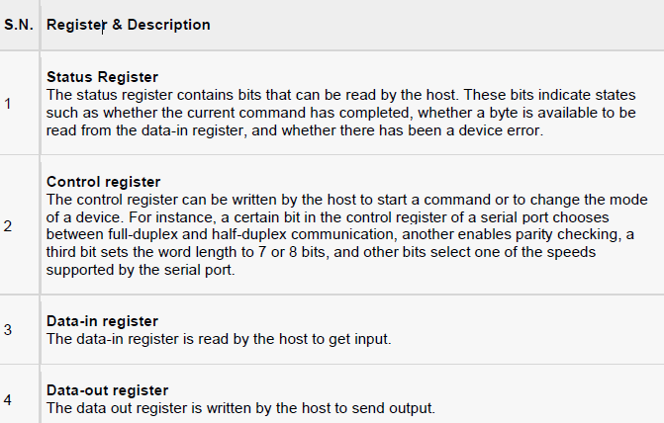
I/O devices
I/O Devices can be categorized into following category.
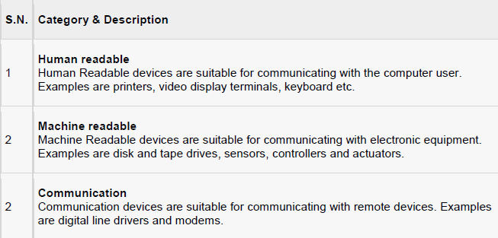
Following are the differences between I/O Devices
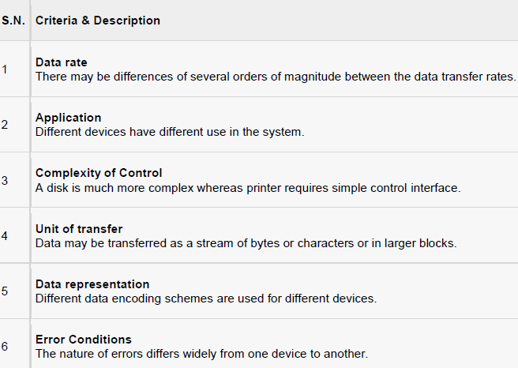

Interrupts
Usually, controller registers have one or more status bits that can be tested to determine if an output operation is complete or if new data is available from an input device. A CPU can execute a loop, testing a status bit each time until a device is ready to accept or provide new data. This is called polling or busy waiting.
In addition to status bits, many controllers use interrupts to tell the CPU when they are ready to have their registers read or written
most interface devices provide an output which is logically the same as the "operation complete" or "data ready" status bit of a register, but which is meant to be used to drive one of the IRQ (Interrupt ReQuest) lines of the system bus. Thus, when an interrupt-enabled operation completes, it interrupts the CPU and starts the interrupt handler running.
.

Principles of I/O Software
Goals of the I/O Software
A key concept in the design of I/O software is device independence. What this means is that it should be possible to write programs that can access any I/O device without having to specify the device in advance. For example, a program that reads a file as input should be able to read a file on a floppy disk, on a hard disk, or on a CD-ROM, without having to modify the program for each different device.
Closely related to device independence is the goal of uniform naming. The name of a file or a device should simply be a string or an integer and not depend on the device in anyway.
Another important issue for I/O software is error handling. In general, errors should be handled as close to the hardware as possible. If the controller discovers a read error, it should try to correct the error.
Still another key issue is synchronous (blocking) versus asynchronous (interrupt-driven)
transfers. Most physical I/O is asynchronous the CPU starts the transfer and goes off to do
something else until the interrupt arrives.
Another issue for the I/O software is buffering. Often data that come off a device cannot be stored directly in its final destination.
Device driver
Device driver is a program or routine developed for an I/O device. A device driver implements I/O operations or behaviors on a specific class of devices. The job of a device driver is following.
- To accept abstract request from the device independent software above it.
- To see to it that the request is executed.
The basic function of the device-independent software is to perform the I/O functions that are common to all devices and to provide a uniform interface to the user-level software

Application I/O Interface
Application I/O Interface represents the structuring techniques and interfaces for the operating system to enable I/O devices to be treated in a standard, uniform way.
Following are the characteristics of I/O interfaces with respected to devices.
- Character-stream / block - A character-stream device transfers bytes in one by one fashion, whereas a block device transfers a complete unit of bytes.
- Sequential / random-access - A sequential device transfers data in a fixed order determined by the device, random-access device can be instructed to seek position to any of the available data storage locations.
- Synchronous / asynchronous - A synchronous device performs data transfers with known response time where as an asynchronous device shows irregular or unpredictable response time.
- Sharable / dedicated - A sharable device can be used concurrently by several processes or threads but a dedicated device cannot be used.
- Speed of operation - Device speeds may range from a few bytes per second to a few gigabytes p/s.
- Read-write, read only, or write only - Some devices perform both input and output, but others support only one data direction that is read only.
Clocks
Clocks are also called timers. The clock software takes the form of a device driver though a clock is neither a blocking device nor a character-based device. The clock software is the clock driver. The exact function of the clock driver may vary depending on operating system. Generally, the functions of the clock driver include the following.
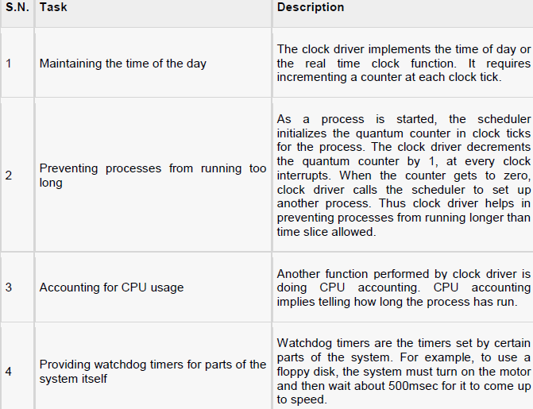
Kernel I/O Subsystem
Kernel I/O Subsystems responsible to provide many services related to I/O. Following are some of the services provided.
- Scheduling - Kernel schedules a set of I/O requests to determine a good order in which to execute them by Kernel I/O scheduler rearranges the order of the queue to improve the overall system efficiency and the average response time experienced by the applications.
- Buffering - Kernel I/O Subsystem maintains a memory area known as buffer that stores data while they are transferred between two devices.
- Caching - Kernel maintains cache memory which is region of fast memory that holds copies of data. Access to the cached copy is more efficient than access to the original.
- Spooling and Device Reservation - A spool is a buffer that holds output for a device, such as a printer, that cannot accept interleaved data streams
- Error Handling - An operating system that uses protected memory can guard against many kinds of hardware and application errors.

